# Design:

3) What is design?

Another phase in the software development life cycle is designing. Designing is important in my project because it helps to ensure that all the necessary requirements, operation and features which are decided the predecessor process.

3.1 structural modelling:

It represents the static aspect of the system. It shows those parts of diagram which forms the main structure and therefore stable. They are not utilizing time related concepts, it doesn’t show the details of dynamic behavior. It may show relationships to the behaviors of the classifiers exhibited in the structure diagrams. The structure diagram elements represent the meaningful concept of a system and may include abstract, real world and implementation concepts.

3.1.1 Final class diagram:

A static structure diagram which describes structure of a system at the level of classifiers of the system, subsystem or component, different relationships between classifiers, their attributes and operations, constraints. Notations utilized for class chart are:

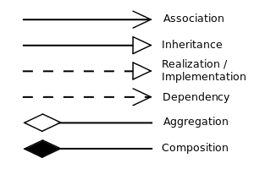

Definition:

A class diagram can be defined as the methods and variables in an object which is a specific entity in a project or the unit of code representing that entity. Which then shows the relationship and source code dependencies among classes.

Justification:

I have used class diagram in my project because:

1. It helps to think out the structure of the classes and how they will interact with each other.
2. It provides a model for maintaining the program to get an overview of how the system is structured.
3. It is necessary for the object-oriented programming.

Diagram:

Diagram explanation:

* + 1. Data-Flow diagram:

Data flow diagram is a methodology of graphical structural analysis and information system design, which describes the sources external in respect to the system, recipients of data, logical functions, data flows and data stores that are accessed. There are some reasons for using data flow diagram and the reasons are as follow:

* It helps in logical information flow of the system.
* It can be used in determination of physical system construction requirements
* It has simplicity of notation
* It helps in establishment of manual and automated system requirements.

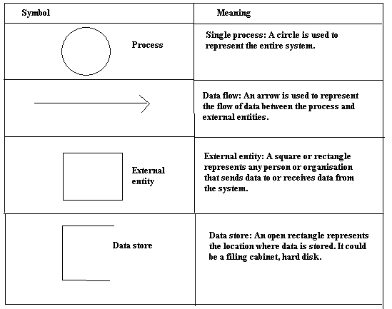

Diagram:

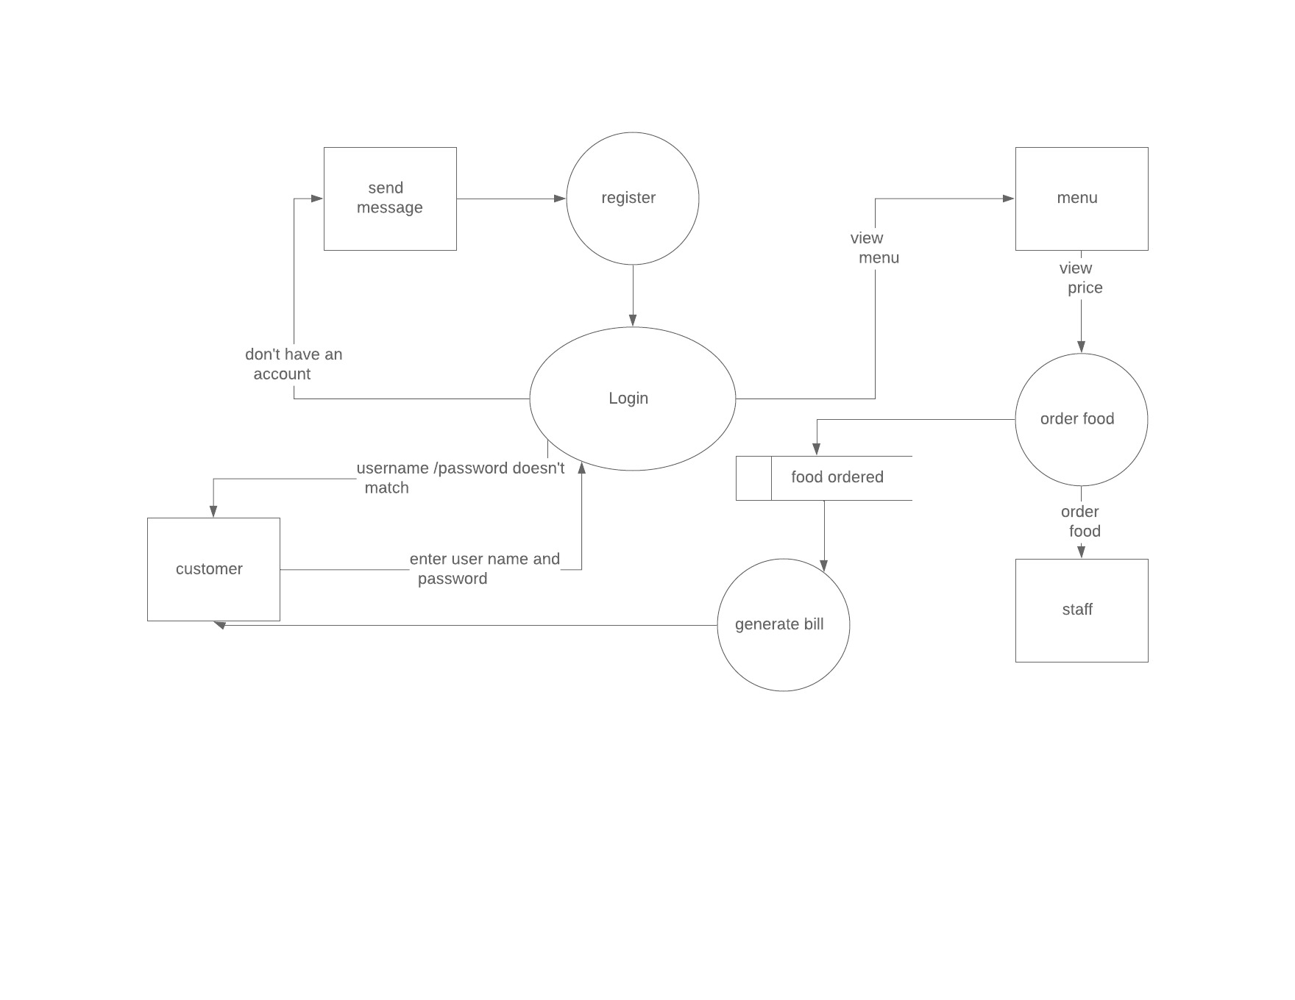

Figure 1 Data Flow Diagram

Above diagram, Restaurant Management system is web based system. Here I have drawn a data flow diagram which shows the flow of data that are done in the system. In the diagram above a customer can register an account if they don’t have an account. After logging in into the system user can view menu, price and order food. The system will automatically generate bill based other users order. Staff of the restaurant can view orders of customers and provide them food.

* 1. Behavioral modelling:

It is act of guiding the employees or any other things how to do something by showing them the standard modeled behavior. It is one of the process is of the premise that people tend to inevitably learn things they may see in the coming days or future. It encouraged to act as well as respond according to the situations about their specific roles. There are many behavioral modelling and the suitable modelling I have done in my project are listed below:

3.2.1 Activity diagram:

It is a flowchart to represent the flow from one activity to another activity and that activity can be described as an operation of the system. It captures the dynamic behavior of the system. It is used to construct the executable system by using forward and reverse engineering techniques.

While representing the diagram notation are used are given below:

|  |  |  |  |
| --- | --- | --- | --- |
| No. | Name of Notation | Notation | Description |
| 1. | Swim lane |  | It depicts the activities and flow for certain role or participants. |
| 2. | Initial state |  | It is the starting point of the workflows. |
| 3. | Final state |  | It is the final point where the process terminates |
| 4. | Action/activity |  | Major tasks that takes place in a system is illustrated in activity. |
| 5 | Decision |  | It supports the conditionals in activities |
| 6. | Control Flow |  | It represent the path for passing data |
| 7. | Send signal |  | Used to represent that the signal has been sent. |
| 8. | Fork |  | Used to represent a flow that may be branched into two or more parallel flows. |

Diagram: 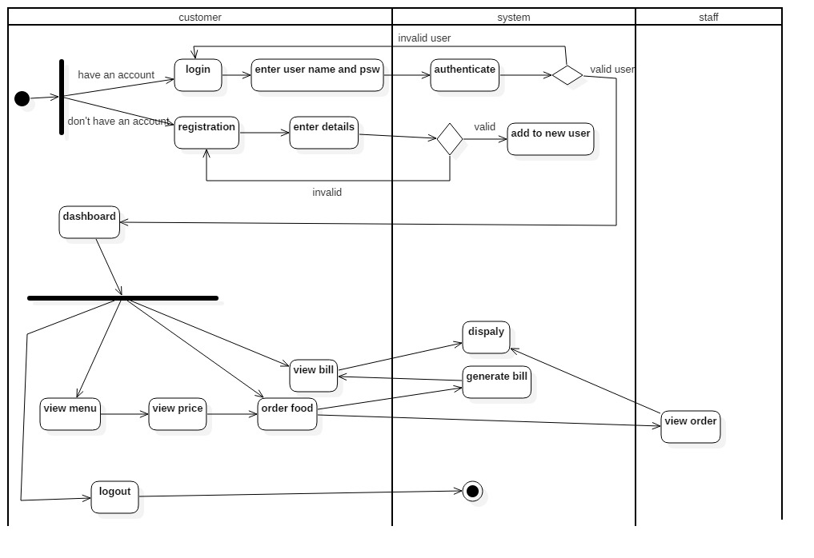

Figure 2 Activity Diagram Users

In above activity diagram, it shows that an individual should be register first to get access into the system to know all the features in the particular application. After registration a user can login into the system by giving correct information of username and password in the system. Verification in the system, login should be done first and after that access of login cane be act as verfication being authorized users. When an authorized user is accepted they are allowed to use the system if they fails then they get back in login page again. After being apporoved, they are allowed to get into the system and use the the further features and they can update their information and use the system as they want it to use. After using the system they can close the application by clicking in the log out option of the system. Once they are logged out the system they cant go back they should again go back to login page and get in the system.

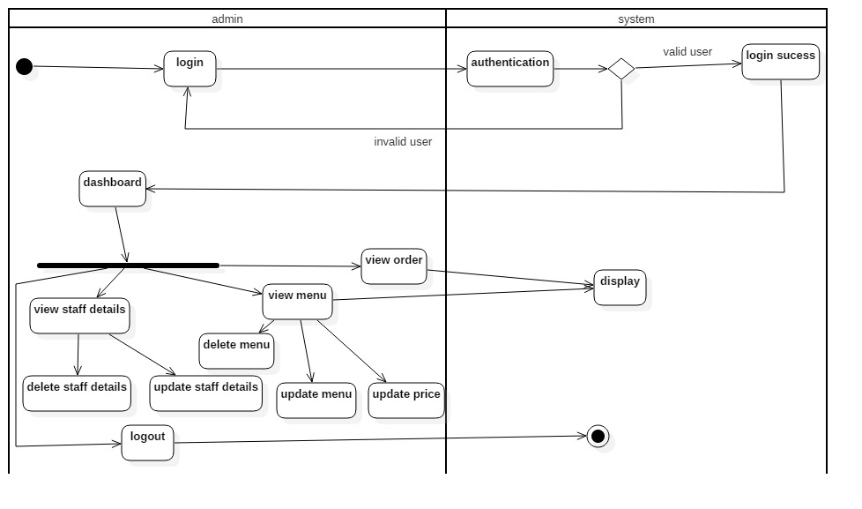

Figure 3 Activity Diagram Of admin

The above activity diagram, it shows the functions done by admin in the system. Before getting into the system admin also need to get log in into the system because it is not necessary to register by being an admin. Being an admin it should be able to perform different activities in the system by adding details of users in the system. Admin cannot update and delete the data of any users which are private but can delete the account which are inactive.

* + 1. Sequence diagram:

It is interactions among classes in terms of an exchange of messaged over time. It is a good way to visualize and validate various run runtime scenarios. Sequence diagram is also known as event diagrams. This diagram helps to predict how a system will behave and discover responsibilities a class may need have in the process of modeling a new system.

Sequence Diagram is used in project in following reasons:

* It is used to show the interactions between objects in the sequential order.
* It helps in communications and shows object interact.
* It is used as requirements document to communicate requirements for a future system Implementation.

Notation used in sequence diagram:

|  |  |  |  |
| --- | --- | --- | --- |
| No. | Name of notation | Notation | Description |
| 1. | Lifeline |  | It represents the sequential events taken place in particular time |
| 2 | Message |  | Used to send and reply the messages within the objects |
| 3. | Recursive message |  | Used when the object need to send message to itself |

Diagram:

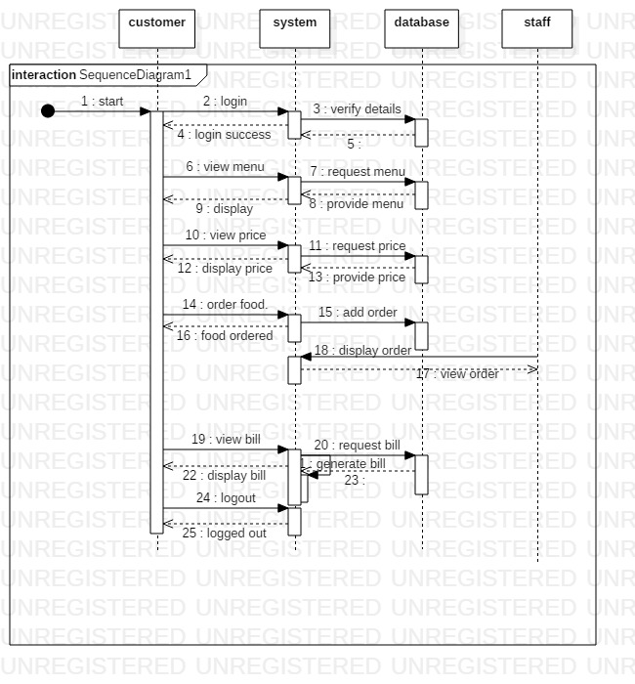

Figure 4 Sequence Diagram of Customers

The above sequence diagram of customers accepts all the participations which are reasonable between inquiries from customer side. It shows about how a customer can make communication with the structure when signing in, including, refreshing, seeing profile customer and giving message to different customers and about log out. It likewise sets up circle and if else condition in the midst of different associations.

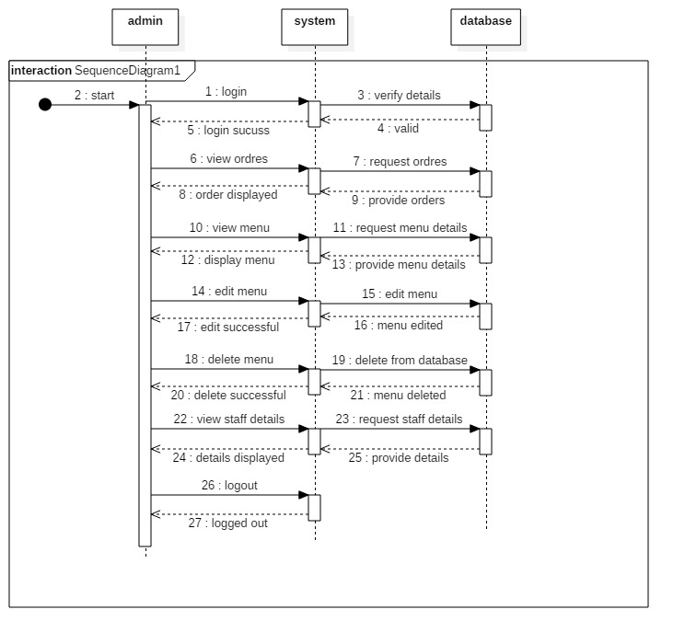

Figure 5 Sequence Diagram of admin

* 1. Database modelling:

It is a collection of processes that facilitate the designing development, implementation and maintenance of enterprise data management system.

3.3.1 Data dictionary:

It is a file or a set of files that contains a database’s metadata. Data dictionary is a collection of names, definitions and attributes about data elements that are being used or captured in a database, information system, or part of research project. It is a crucial component of any relational database. Only database administrators interact with the data dictionary.

Data Dictionary is useful due to following reasons:

* Assist in avoiding data inconsistencies across a project
* Help define conventions that are to be used across a project
* Provide consistency in the collection and use of data across multiple members of a research team
* Make data easier to analyze
* Enforce the use of Data Standards

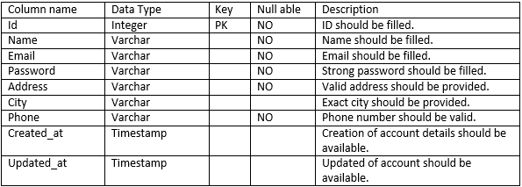

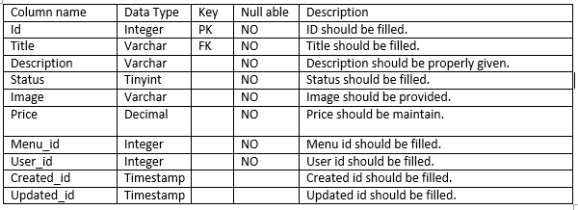

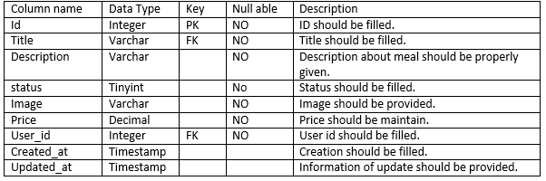

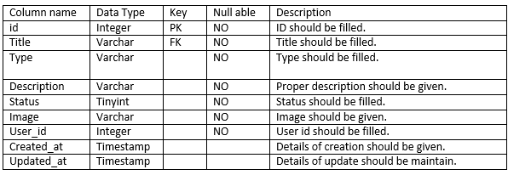

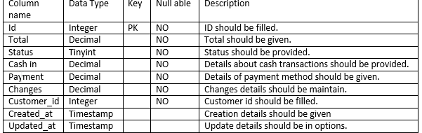

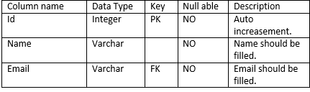

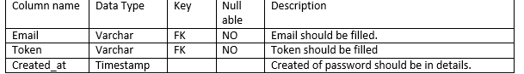

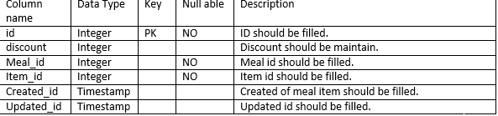

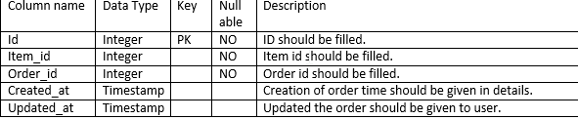

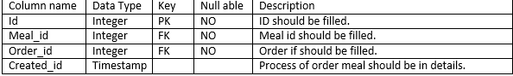

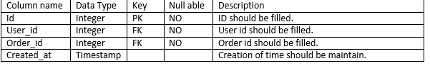

* + 1. ER diagram:

Entity diagram is a type of flowchart that illustrates how “entities” such as people, objects or concepts relate to each other within a system. They mirror grammatical structure, with entities as nouns and relationships as verbs. An entity is a real-world item or concept that exists on its own. Entities are equivalent to database tables in a relational database, with each row of the table representing an instance of that entity.

Entity Diagram is useful due to following reasons:

* It is used in database design.
* It is used to analyze database troubleshooting.
* It helps in business information system.
* It helps is business process re-engineering.
* It can be used to do research.

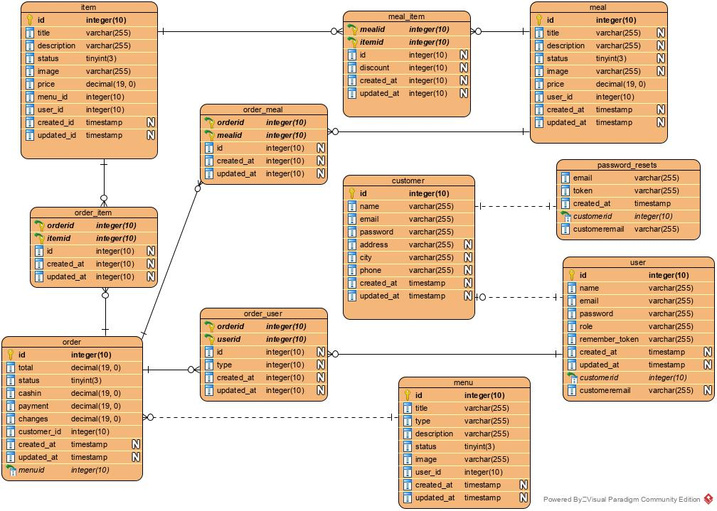

Figure 6 Entity Relationship

Above Entity Diagram shows the relationship of entity among the tables and entities where eleven table is created as item, order item, order, order meal, order user, meal item, customer, menu, meal, password resets, user.

* 1. UI modelling:

User Interface Design is the discipline of designing software interfaces for devices, ideally with a focus on maximizing efficiency, responsiveness and aesthetics to foster a good user experience. Designers aim to create designs users will find easy to use and pleasurable. UI design typically refers to graphical user interfaces but also includes others, such as voice-controlled ones. The interface should allow a user to perform any required tasks to complete the function of the product or service.

3.4.1 Prototype:

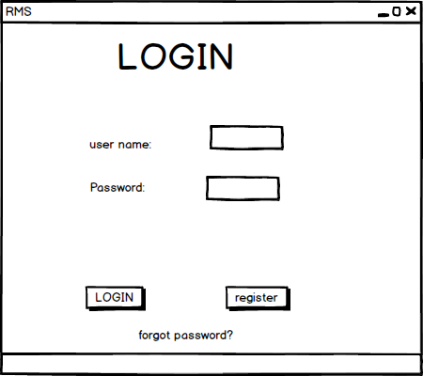

Figure 7 Login Page

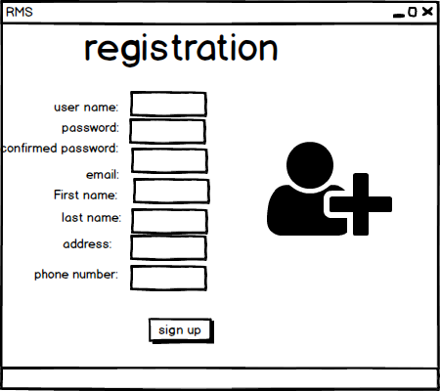

Figure 8 Registration Page

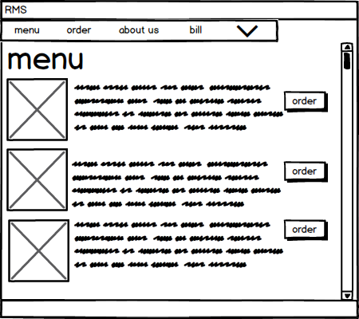

Figure 9 Menu Page

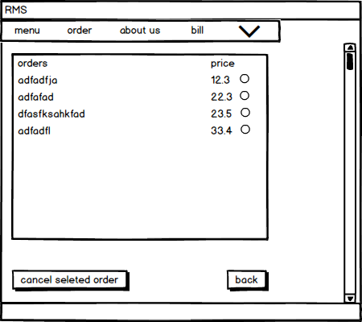

Figure 10 Order Page

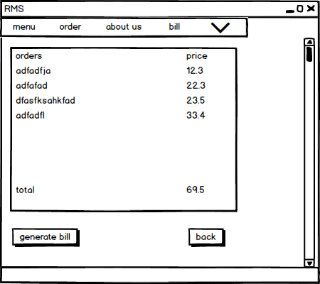

Figure 11 Generate Bill

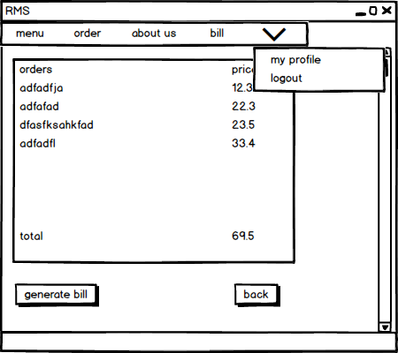

Figure 12 profile and Log out Option

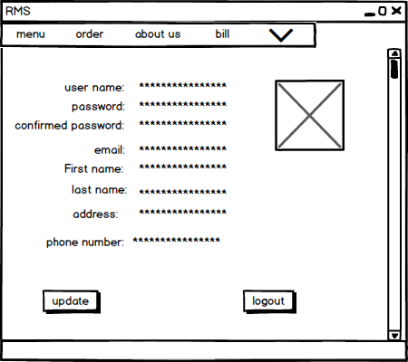

Figure 13 User Profile

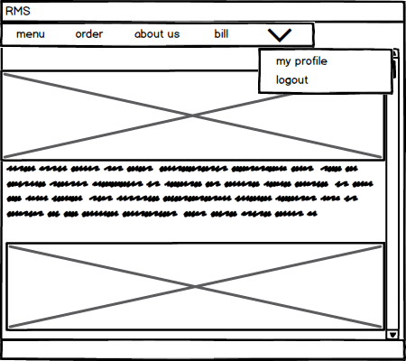

Figure 14 Front Page

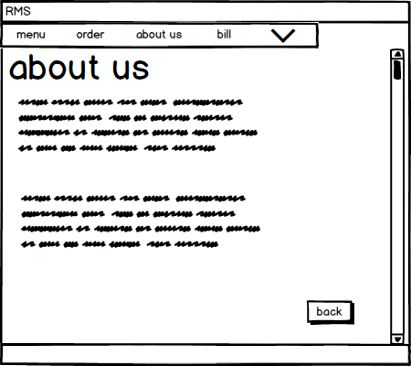

Figure 15 About us